**Angular Interview Questions**:

# What is angular?

Angular is a component based framework we are dealing with the components and it’s a “Single page Application”

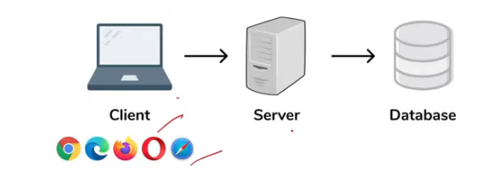

Browser understand css,html,JS

Why we have angular because the we need the structure for the complex project and maintain the application and component based so that it can be scalable.

# What are the advantages of angular

1. Single page application can be build using angular as well as java script   
   but we can built the component based application using Angular
2. It’s OOP’s friendly and give us the structured application
3. It’s a cross platform & Open source
4. Reusable code (Services)

# Why we have NPM & Node.js in Angular:

Node.js & Angular both was developed by google only so they make the libraries common for both.

In angular we have NPM it’s a central repository which we can use to have external open source library dependency.

# Difference between Angular & Angular Js

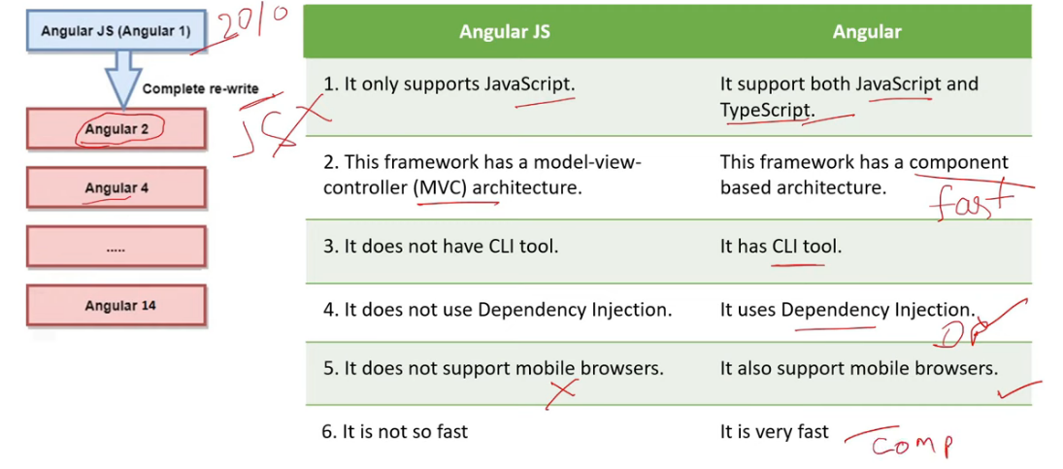

# Typescript Vs JavaScript

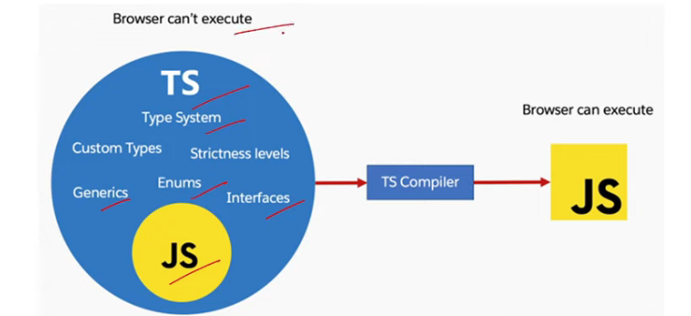

Browser don’t know about the TS so at the compile time only ts code converts it into the JS then browser start it’s execution and render the views

# Component in angular:

1. Selector Template:  
   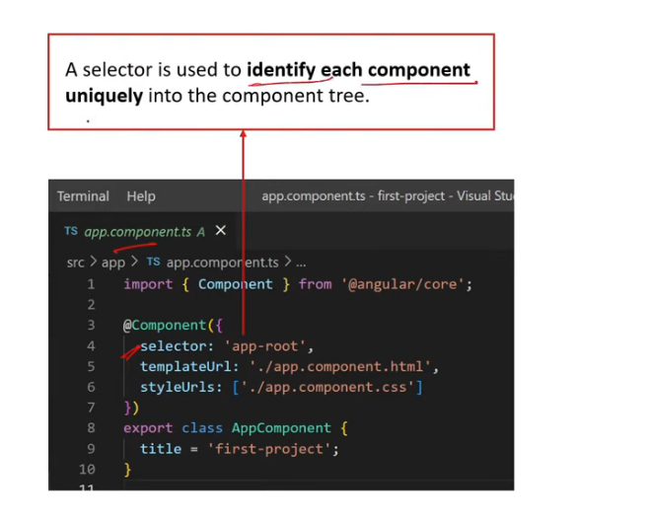
2. What is app.module.ts  
   Module is a place where you can group components,directives,pipes & services which are related to the application.

# How and angular apps get loaded and started:

First it will hit the index.html then it will invoke the main.ts(entry point of the file it compiles the web app & bootstraps the appModule to run in the browsers.

App Module : this file will then bootstrap the AppComponent

App-Component or App-root is the html file which you will see finally

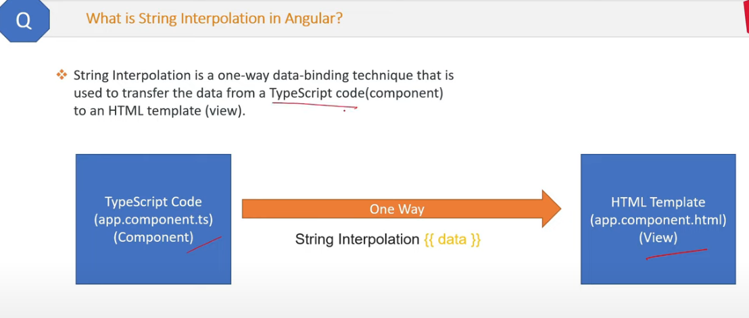

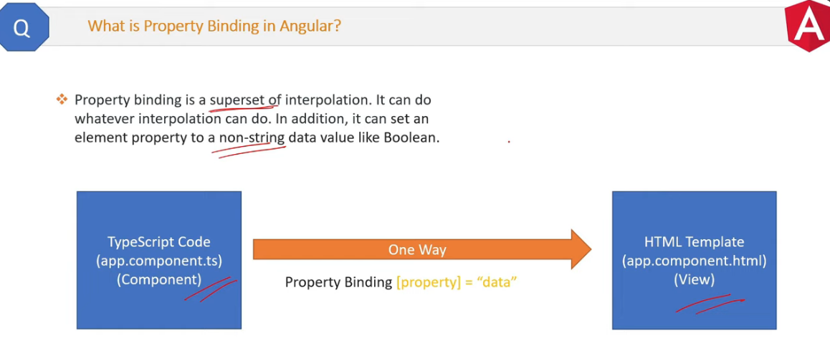

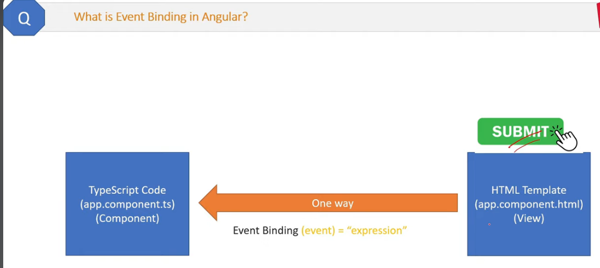

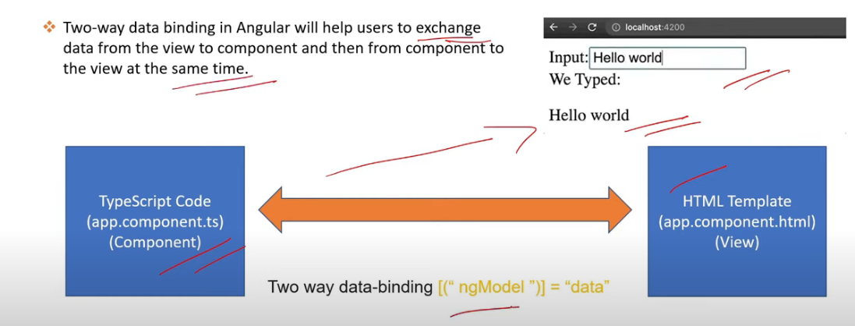

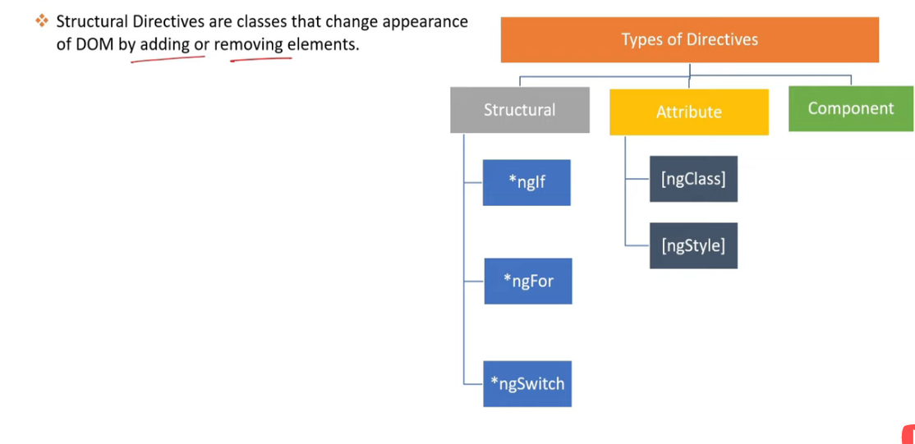

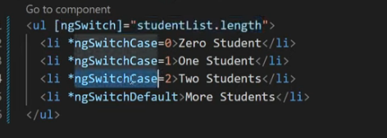

# What is ngStyles directive in angular ?